Using Health Data in ArcGIS Pro – Data cleaning, geocoding, and health data visualization

In this tutorial you are going to become familiar with adding health data to a map that does not have geographic coordinates. If the data provided has an address, you can use a **Geocoding** tool to match the addresses to geographic points in ArcGIS Pro. It then goes over some techniques for better visualizing the health data.

**OBJECTIVES**

* **Clean up excel files with health information and upload into ArcGIS Pro**
* **Conduct address matching to geographic coordinate analysis (geocoding)**
* Adding joins between shapefiles and excel files
* Create meaningful maps

Requirements:

1. Data from the Practice Exercises 3 folder. Sources:
   1. Health clinic locations practicing care for hypertension (Excel): Tennessee Heart Health Network. (accessed on 09/14/2024). Clinic locations practicing care for hypertension. <https://tnhearthealth.org/maps-portal/>
   2. Hypertension data (Excel): PolicyMap. (accessed on 09/14/2023). Crude percent of high blood pressure among adults in 2019. <https://policymap.com>
   3. Minority census tract data (Excel):
      1. Source data is public Home Mortgage Disclosure Act (HMDA) Data for 2019 as of 2022-06-21.
      2. Census tract minority population percentages are determined using the 2020 Census Redistricting Data, from the U.S. Census Bureau.
      3. Tract to ZIP mapping is determined by Q4 2021 USPS ZIP Code Crosswalk data, as published by HUD.
      4. 2020 block group to 2010 census tract mapping obtained from IPUMS National Historical Geographic Information System (NHGIS) at the University of Minnesota (<https://www.nhgis.org/about-ipums-nhgis>). For 2020 block groups spread across more than one 2010 census tract, we kept the pairing with the greatest overlap.
   4. City boundaries (Polygon): State of Tennessee Downloadable GIS Data <https://tn-tnmap.opendata.arcgis.com/search?tags=boundaries>
   5. Census tract boundaries (Polygon): U.S. Census Bureau <https://myutk.maps.arcgis.com/home/item.html?id=ed71ab73dac14a93a7cd1020352bdfbc>
   6. Zipcode boundaries and Shelby County boundary (Polygon): U.S. Census Bureau <https://www.census.gov/geographies/mapping-files/2018/geo/carto-boundary-file.html>

Section 1: Data Cleaning

## Section 1.1: Clean up excel files with health information and upload into ArcGIS Pro

Researchers will get a lot of health information distributed to us in excel files. Sometimes this data needs minimal cleanup, and sometimes it can need a lot of cleaning in order to make it easily readable by ArcGIS Pro.

For the first part of this tutorial, you will learn how make excel files easily readable for ArcGIS Pro using three different excel files.

1. Navigate to the folder that includes the excel file data for Practice Exercise 3 and open **HealthClinicLocations.xlsx**. The file will look like the figure below.

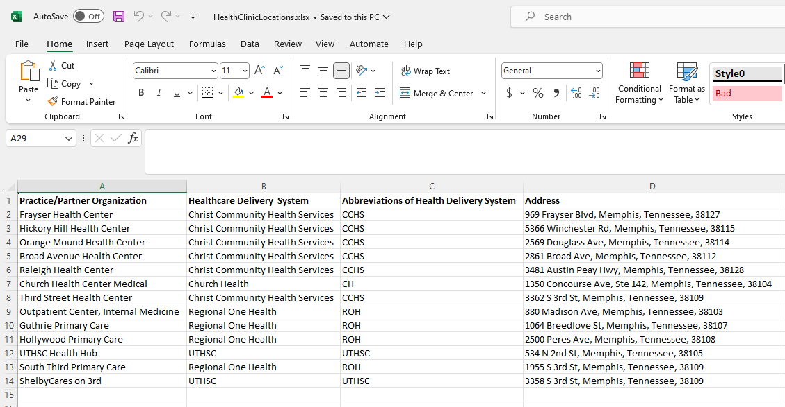

1. When trying to do address matching for later, you will want the address to be separated by street address, city, state, and zipcode. Therefore, we will have to split the last column into separate columns. Create the headers for each of the columns.

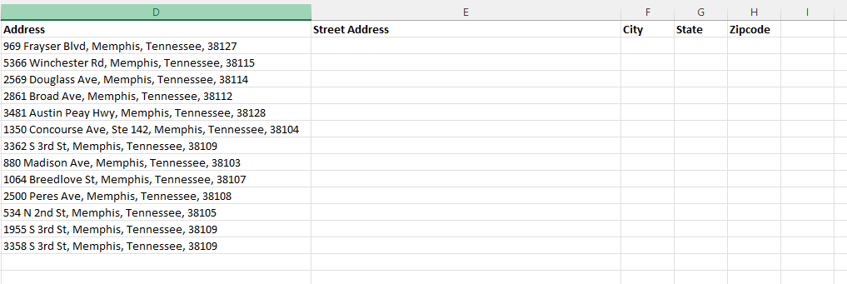

1. Fill in the appropriate information into each of the new columns. It will look like the figure below. **Note: To make things easier, you can copy and paste the Address into the Street Address column and delete after the street. All cities are Memphis, so you can type it in once and autofill. Same with all states: Tennessee. For the zipcode, you can copy and paste the address and delete everything before the zipcode.**

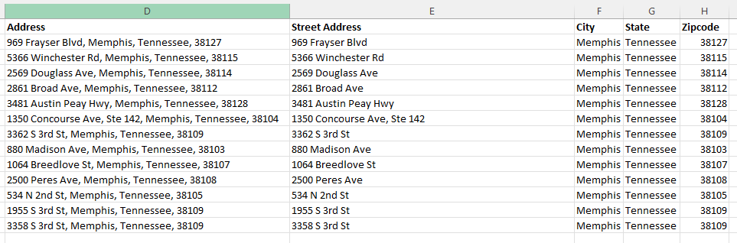

1. When you finish, save the file by clicking **File** in the upper left of the Excel environment and selecting **Save**.

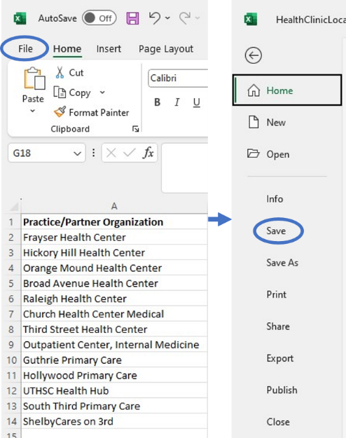

1. Now we have two more excel files to clean up. Next, open **HypertensionData2019.xlsx**. This file is mostly ready. However, you will notice that under state, the values are **Tennessee (State)**. We want this column to only say **Tennessee**. You can quickly fix this by conducting a replacement for that column. Click the drop-down arrow by **Find & Select** in the top panel of the Excel environment and choose **Replace**. Make sure to highlight the column for **GEOID** and check that the **Number** section says the column is **Text**. If not, use the drop-down arrow to choose that option. When you finish, save the file by clicking **File** in the upper left of the Excel environment and selecting **Save**. Just as before.

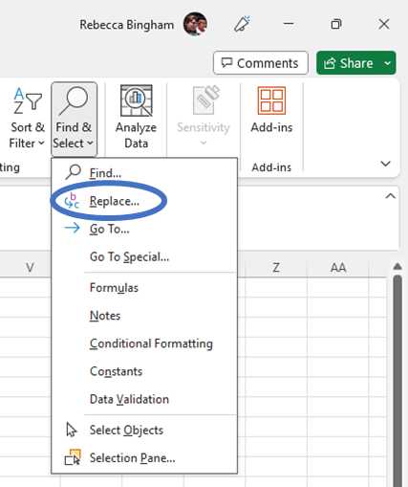

1. Lastly, we will clean up the **MinorityCensusTracts.xlsx** file. This file is a bit messy. First, you will want to delete the first three rows by clicking at the 1 on the left side of the excel environment and holding as you scroll down to the 3. This will highlight those rows. Then you right-click on the highlighted numbers and select **Delete**.

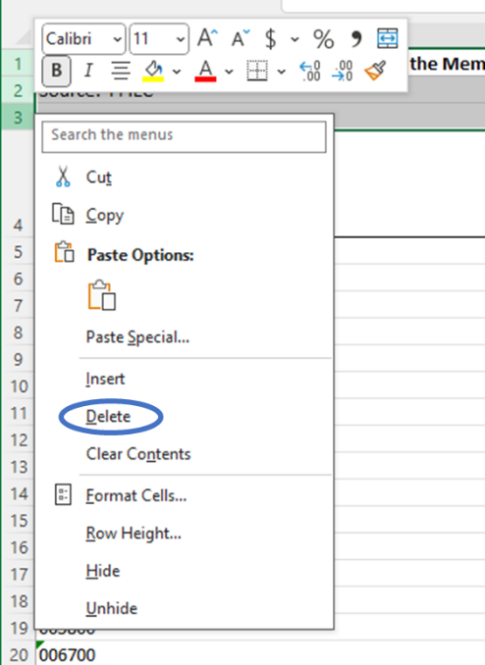

1. Next you will want to delete the information in **cell F1** and condense the columns to just fit the information. You do this by clicking the diagonal arrow in the top left corner to select all and then double clicking the line between columns A and B to condense them. Make sure to highlight the column for **Census Tract** and check that the **Number** section says the column is **Text**. If not, use the drop-down arrow to choose that option. When you finish, save the file by clicking **File** in the upper left of the Excel environment and selecting **Save**. Just as before.

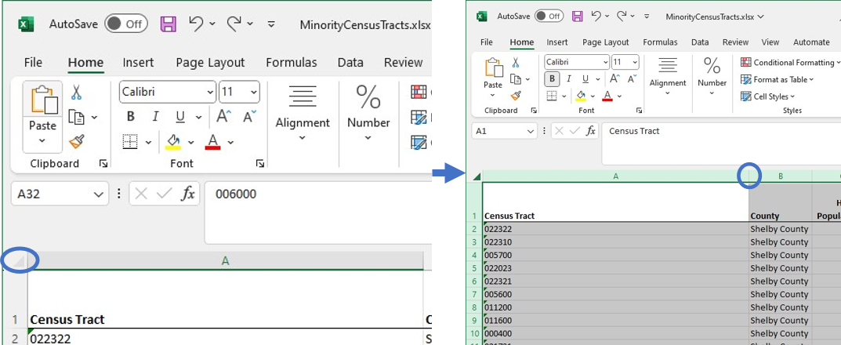

1. Now you are able to upload these excel files into ArcGIS Pro. You will want to open the **Hypertension.aprx** map file by navigating to that folder and double-clicking the file.

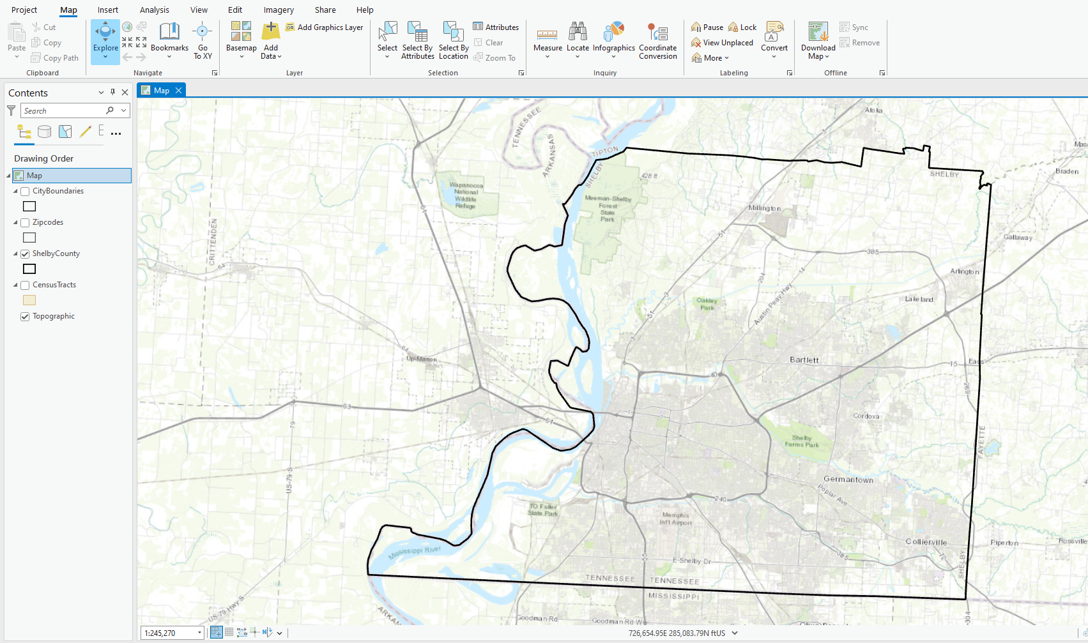

1. Next, you will have to set the data source for each layer in the map file as you did in Exercise 2. A short example of steps is included below. Do this for each layer.
   1. Right-click the **HealthClinics** layer->Choose Properties->Select Data->Click Set Data Source
   2. Navigate to the **Hypertension.gdb** geodatabase in the data folder for this exercise
   3. Choose the **HealthClinics** layer
   4. Click **OK**
2. Next, you will want to click **Add Data** in the top panel of the ArcGIS Pro environment. Navigate to your data folder with the saved excel files and add each of these files in. **Note: for each one, you will click on it and then only one sheet should be visible. Double click that sheet to upload it.**

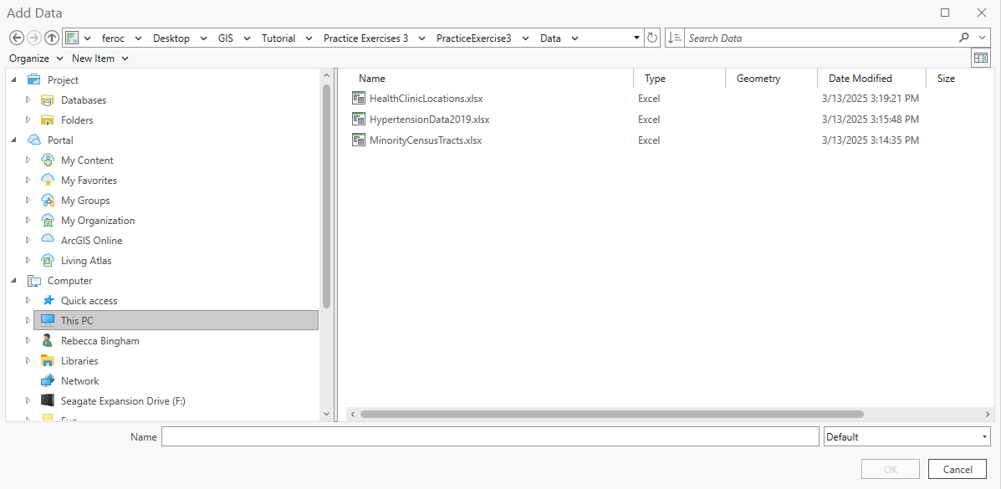

**Section 1.1 Task:** Submit a screenshot with all three cleaned-up data files loaded into ArcGIS Pro.

# Section 2: Geocoding

## Section 2.1: Conduct address matching to geographic coordinate analysis (geocoding)

Next, we must assign geospatial coordinates to our data in order for the data to be visible in the map on ArcGIS Pro. There are a couple of ways to be able to do this. The first is using the addresses in the health clinics file to be matched to geographic coordinates. This will create a point location file. The other is adding relates between an already established shapefile and the standalone tables.

This part of the tutorial will demonstrate how to geocode information that has addresses assigned to it.

1. Continuing within the **Hypertension.aprx**, right-click the **Locations$** table under the **Standalone Tables** section in the **Contents** panel on the left-hand side of the ArcGIS Pro environment and choose **Geocode Table**.

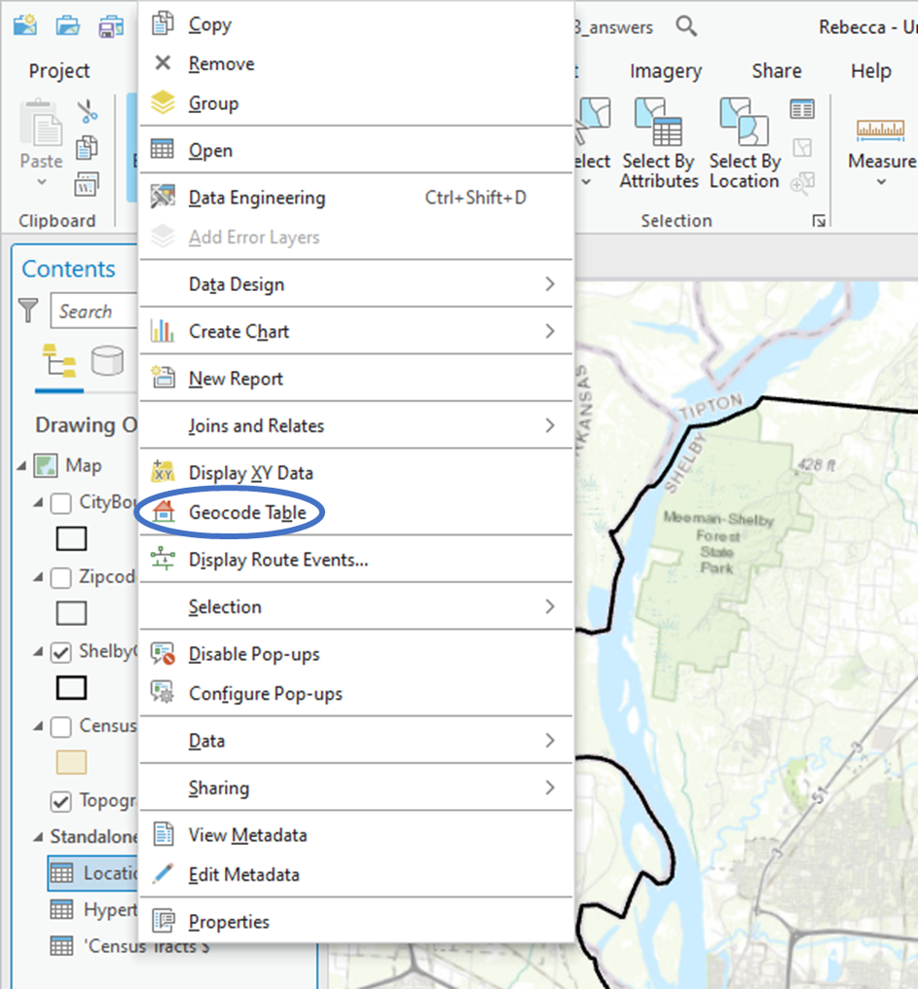

1. This changes the pop-up window on the right hand side of the ArcGIS Pro environment explaining the steps on how to geocode the data. Choose **Start** at the bottom right hand corner of this pop-up window.

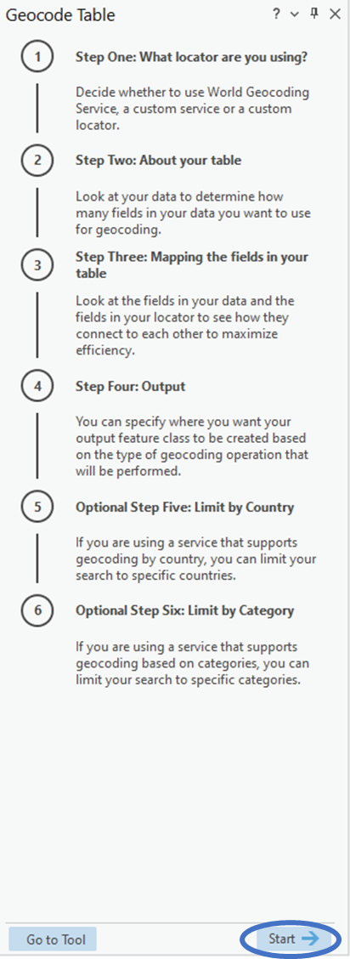

1. This brings you to **Step One**, where you choose the locator that you wish to use. Click the drop‑down arrow next to the blank box under the **Input Locator** and choose **ArcGIS World Geocoding Service.** Then click **Next** on the bottom right-hand side of the pop-up window.

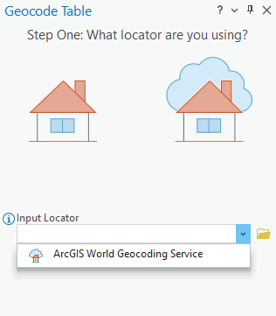

1. This brings you to **Step Two**, where you tell the locator about how the information is set up in your table. Here, you make sure that the **Input Table** says **Locations$**, and you verify that the next text box says **More than one field**.Then click **Next** on the bottom right-hand side of the pop-up window.

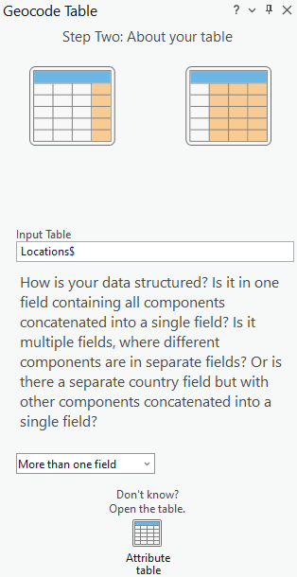

1. This brings you to **Step Three**, where you tell the locator the mapping fields in your table that relate back to information needed for geocoding. Here, you use the drop-down arrows by the data fields to make sure that the **Address or Place** says **Street_Address**, **City** says **City, State** says **State**, and **ZIP** says **Zipcode**.Then click **Next** on the bottom right-hand side of the pop-up window.

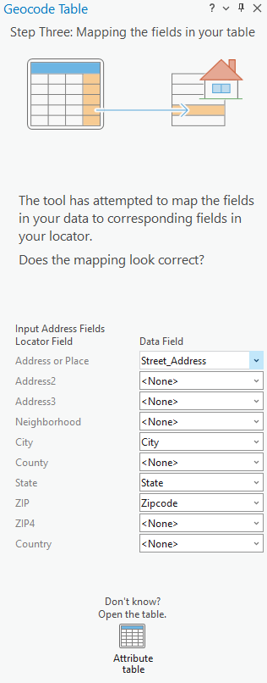

1. This brings you to **Step Four**, where you tell the tool where you want the data to be saved and what to name the new shapefile. Click the folder button next to the output field. Navigate to the **Hypertension.gdb** geodatabase folder and type **HealthClinics** next to **Name**. Select **Save**, then click **Next** on the bottom right-hand side of the pop-up window.

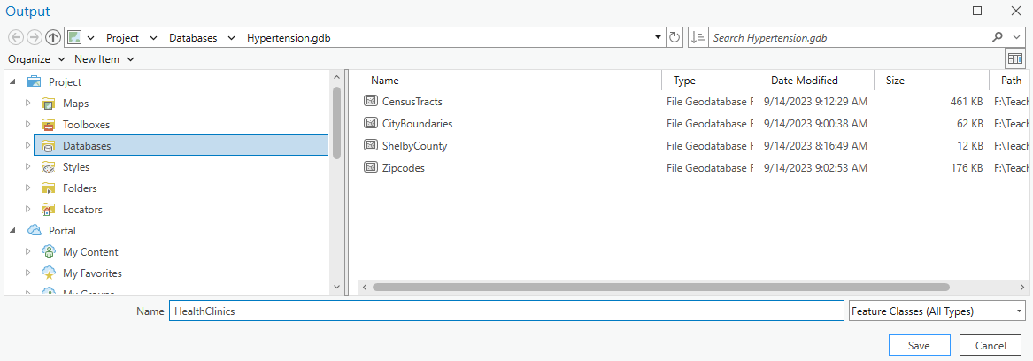

1. This brings you to **Step Five**, where you tell the tool what country(ies) in which your data was located. Click the checkbox next to **United States**. Then click **Next** on the bottom right-hand side of the pop-up window.

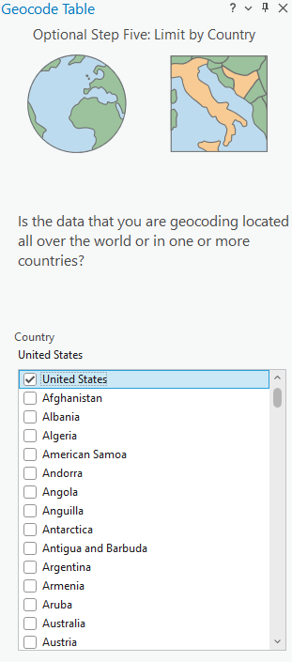

1. This brings you to the last step: **Step Six**. Here you tell the tool what categories you want to limit your address matching to. Click the checkboxes next to **Address** and **Postal**. Then click **Finish** on the bottom right-hand side of the pop-up window.

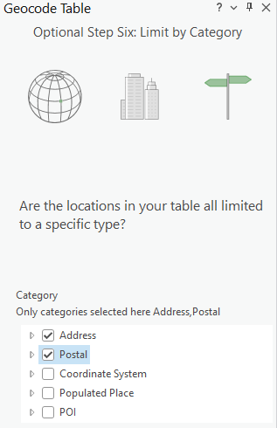

1. Finally, you want to click **estimate credits** in the top of the pop-up window and make sure all other information is filled out correctly. After this click **Run** on the bottom right-hand side of the pop-up window. This will add a new point shapefile with the health clinic locations onto your map. **Save** and **Close** your map project.

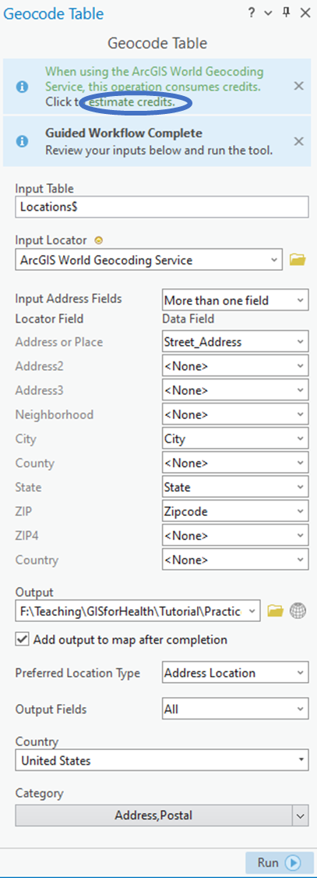

1. Now we want to clean up the attribute data for this new shapefile. Reopen the **Hypertension.aprx** map project. Then, open the attribute table for the **HealthClinics** shapefile. In the attribute table, you can see there is a lot of new information that is not needed. You can clean up this data by deleted some of these columns. First, switch to **Fields View** by clicking the three lines on the top right of the attribute table. To delete a column, right-click the box on the far left of the row select **Delete**. To delete multiple columns use the **ctrl** button on your keyboard to select each of the columns you want to delete, then right-click one of the selected boxes on the far left of the row and select **Delete**. When you choose delete, the boxes on the far right will be highlighted green.

For this task, you will want to delete all columns except the following: **ObjectID \***, **Shape \***, **Status**, **Score**, **Match_type**, **Match_addr**, **X**, **Y**, **USER_Practice_Partner_Organization**, **USER_Healthcare_Delivery_System**, **USER_Abbreviations_of_HealthDelivery_System**, **USER_Address**, **USER_Street_Address**, **USER_City**, **USER_State**, and **USER_Zipcode**.

After choosing to delete all those fields, click the **X** next to **Fields: HealthClinics** to close the fields view. It will ask you if you would like to save changes. Click **Save**. When changes are completed and saved, the fields view window should close. If it does not, you tried to delete a column that cannot be deleted: **ObjectID \***, **Shape \***, **Status**, **Score**, **Match_type**, or **Match_addr**.

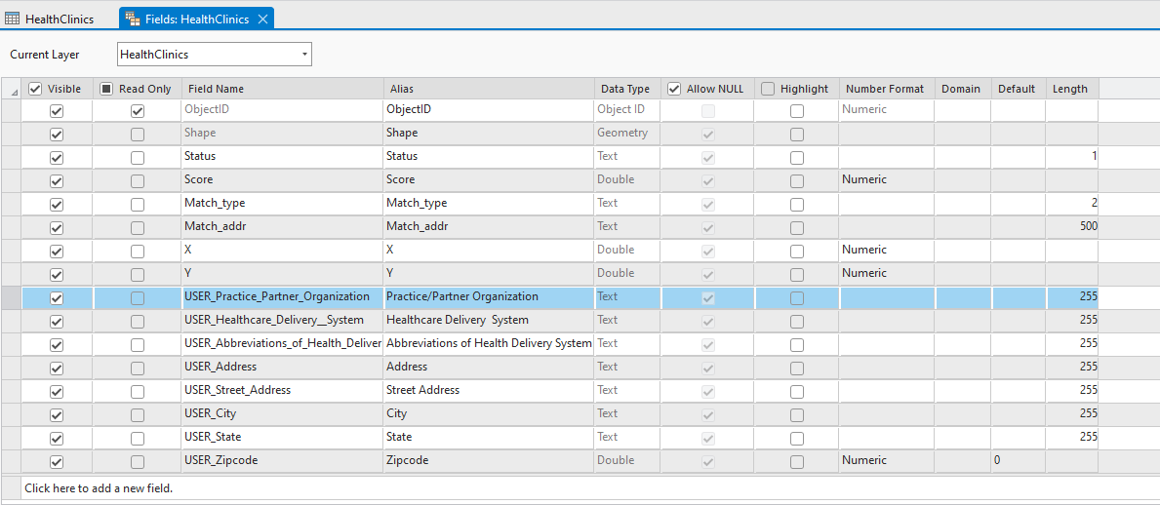

**Section 2.1 Task:** Submit a screenshot of your map on ArcGIS Pro with the health clinics point shapefile.

## Section 2.2: Adding relates between shapefiles and excel files

Many times, you will want to take information from an excel file and add it as extra attributes to a shapefile. You can do this by adding a join between the shapefile and excel file. The result will be adding the information from the excel file as new columns (attributes) to the shapefile.

This part of the tutorial will demonstrate how to add joins between shapefiles and excel files.

1. There are two excel files that have information specific to certain census tracts: **Hypertension** and **‘Census Tracts $’**. We want the data in these excel files to be added as additional information onto the census tracts shapefile. Therefore, we will be adding joins between the **CensusTracts** shapefile and those two excel files and creating a separate shapefile for each. First, you will need to right-click the **CensusTracts** shapefile, hover over **Joins and Relates**, and click **Add Join**.

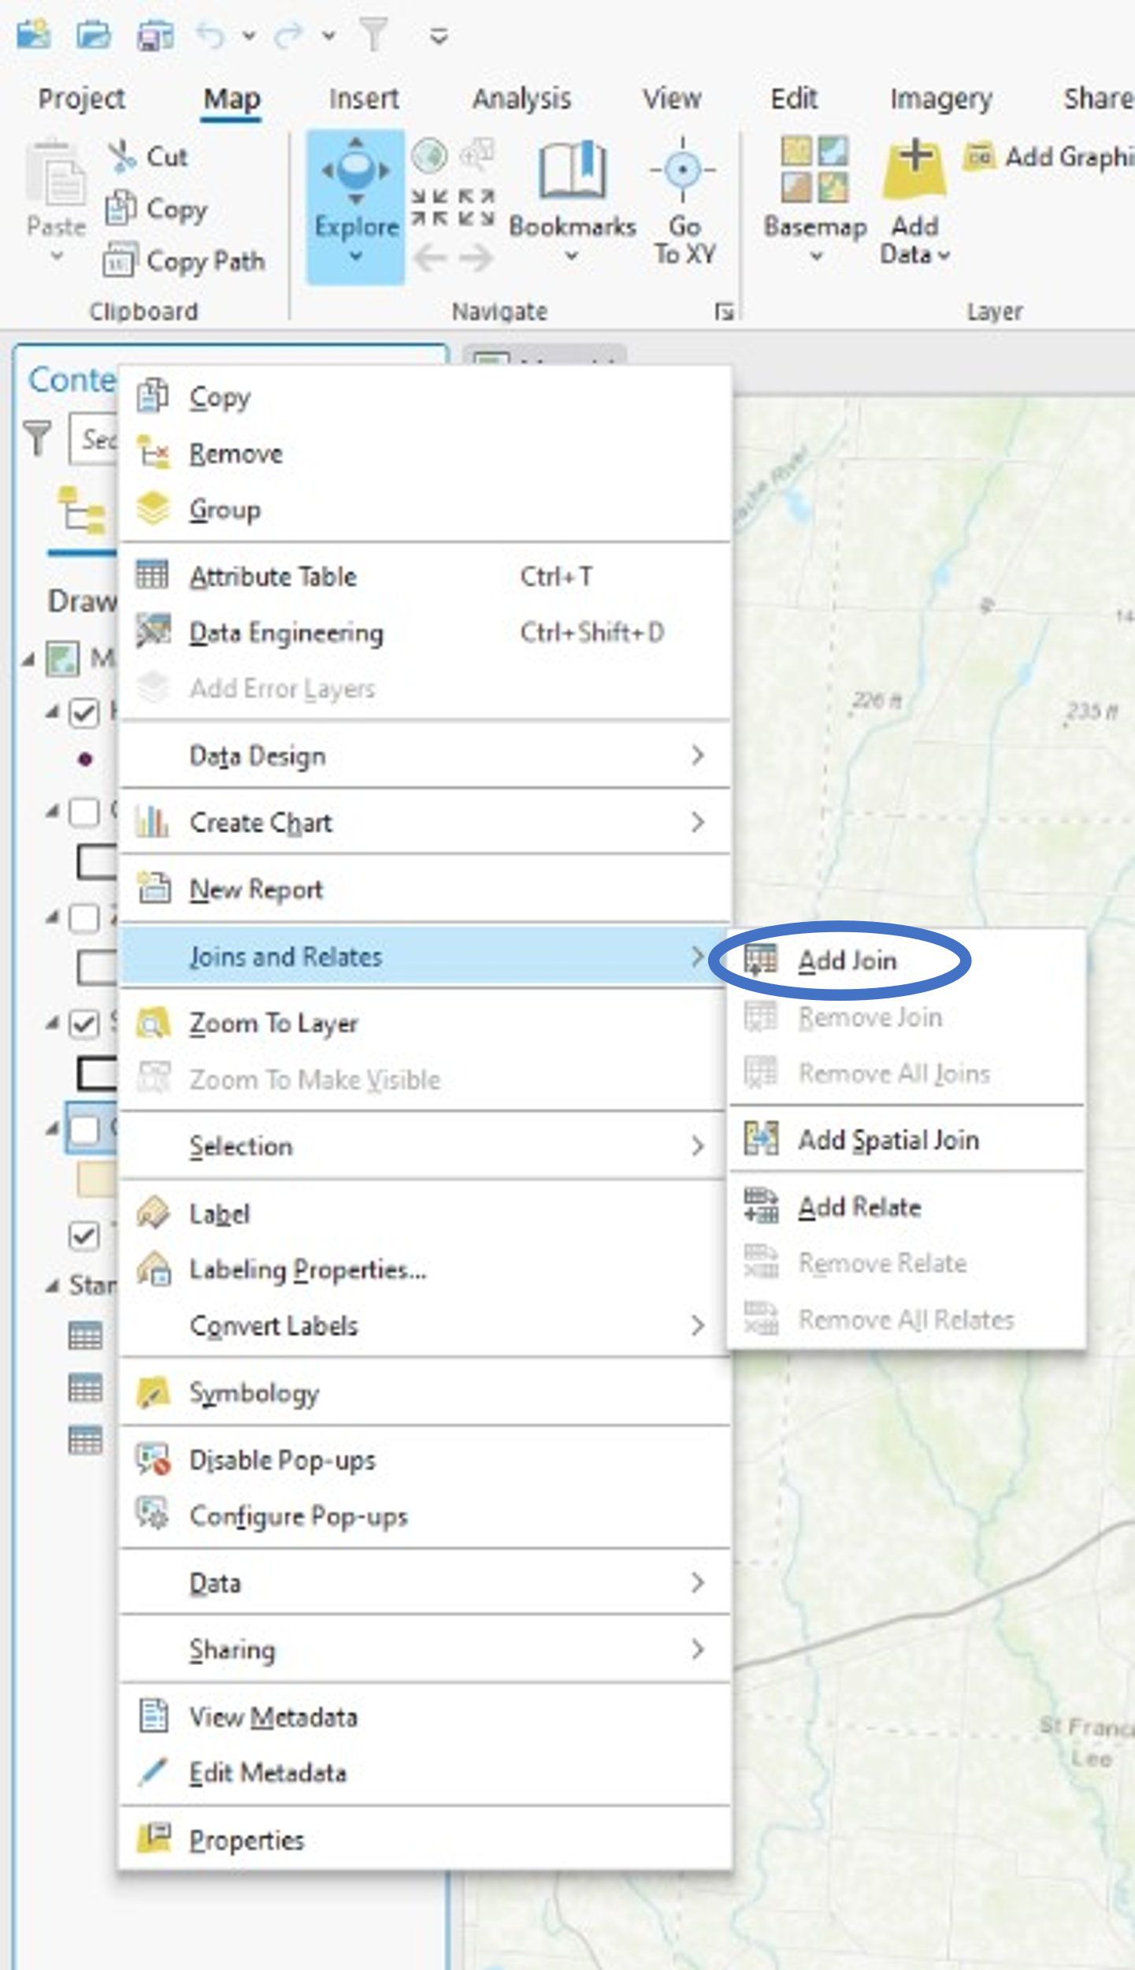

1. A pop-up window will appear. For the **Input Table**, use the drop-down arrow to choose **GEOID**. Under the **Join Table**, use the drop-down arrow to choose **Hypertension$**. For the **Join Table Field**, choose **GEOID**. Keep all other settings the same. Once the pop-up window looks like the figure below, click **OK**.

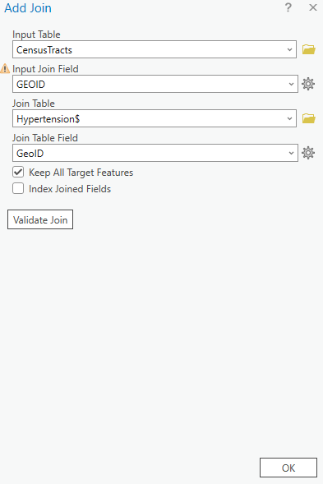

1. Next, you will want to extract this data and save it as a separate shapefile with the hypertension data. Right-click **CensusTracts**, hover over **Data**, choose **Export Features**.

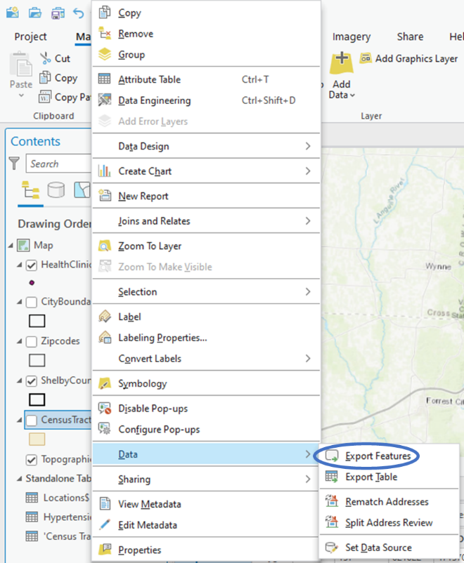

1. A pop-up window will appear. Click the folder next to the text box under **Output Feature Class**. Navigate to the **Hypertension.gdb** geodatabase. Name it **CensusTracts_HighHypertension.** Click **Save**, then **OK**.If you look at the attribute table, you will notice that there are many census tracts with null values for the new data. This is because the **Hypertension$** excel file only had information for those census tracts whose population had high rates of hypertension.

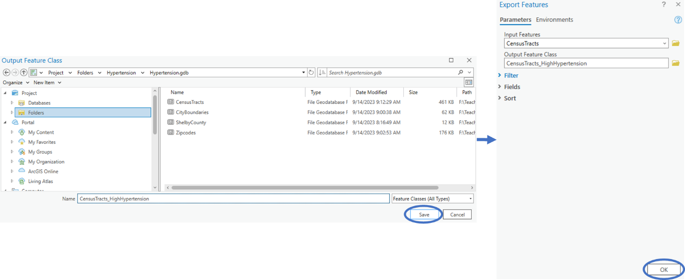

1. Now we will want to add the ‘**Census Tracts $’** attribute information to the **CensusTracts** shapefile. First, you will need to remove any previous joins. Right-click the **CensusTracts** shapefile, hover over **Joins and Relates**, and click **Remove All Joins**. Then click **Yes**.

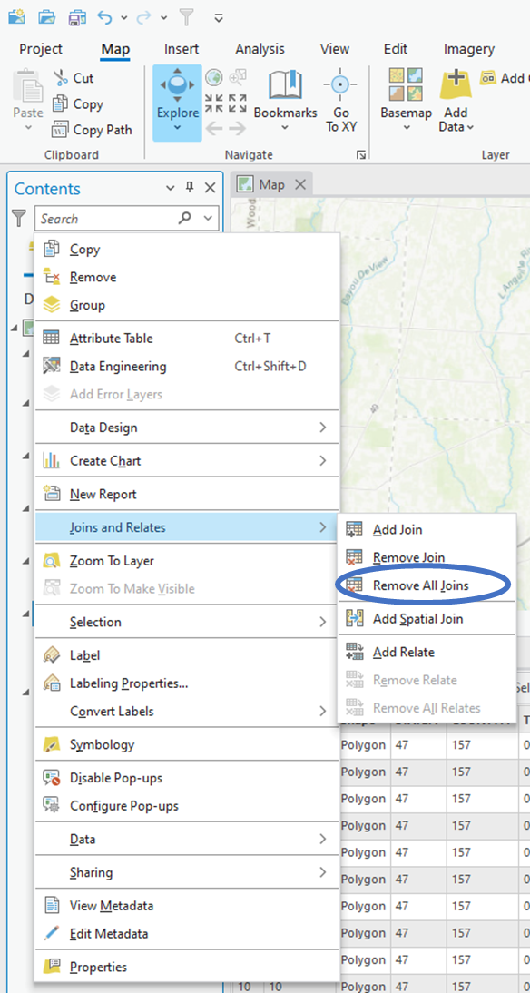

1. Then you can repeat the previous steps to add a join between the **CensusTracts** shapefile and the **‘Census Tracts $’** excel file. Once the pop-up window looks like the figure below, click **OK**.

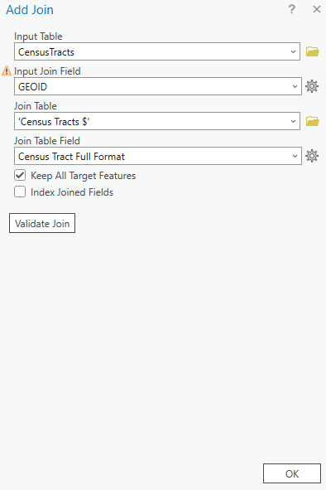

1. Next, you will want to extract this data and save it as a separate shapefile with Black and Hispanic population data. You will want to save it as **CensusTracts_MajorityBlack_Hispanic**.See the figure below. Remember to remove all joins once you have exported the data into a new shapefile.

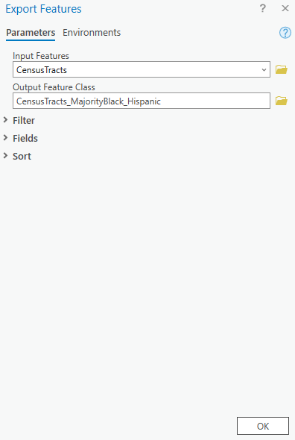

1. Like the **Hypertension$** excel file, the ‘**Census Tracts $**’ excel file only had census tracts whose populations were comprised of majority Black or Hispanic individuals. This leaves a lot of census tracts with null values for the new attributes added to it.Keep this in mind as you move down to future tasks.

**Section 2.2 Task:** Submit a screenshot of your map on ArcGIS Pro with two new shapefiles: **CensusTracts_MajorityBlack_Hispanic** and **CensusTracts_HighHypertension**, along with the attribute table for **CensusTracts_MajorityBlack_Hispanic** open to show the data for it.

Section 3: Health Data Visualization

## Section 3.1: Create meaningful maps

Right now, you have all the data in your map, but it still doesn’t really tell a story. To make a good health data map, you have to present the data in a way that makes it easy for people to quickly understand what you are trying to tell them.

For the final part of this exercise, you will learn how to create meaningful maps.

1. Let’s begin by looking at areas with high hypertension. For this map, you will want to show the viewers where there are areas of high hypertension and how close the health clinics that service people with high hypertension are located. First, turn off any layer not needed to show this information: **CensusTracts_MajorityBlack_Hispanic**.

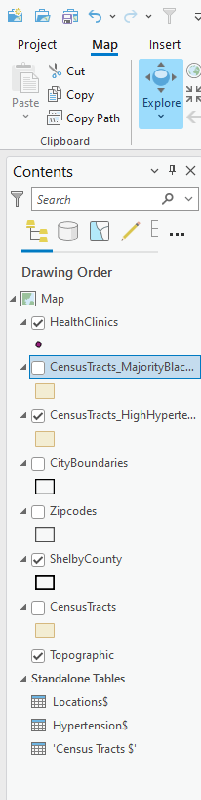

1. We are also going to want to see the city boundaries for this map, so we want to turn on the **CityBoundaries** layer and move it to the top of the map. Turn on the labels for this layer by right‑clicking the layer and selecting **Label**.

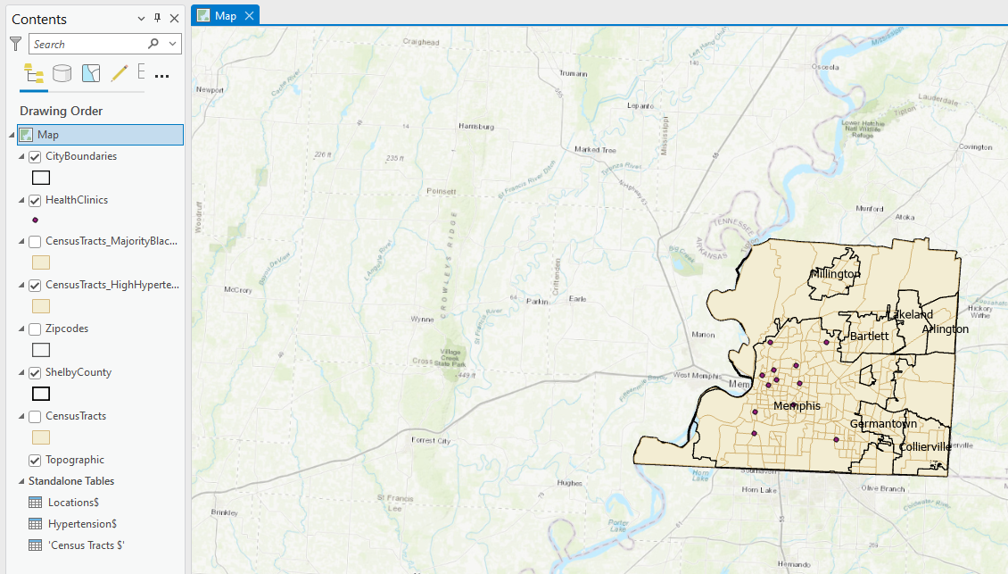

1. Notice that the only health clinic data we have is for the city of Memphis. This is going to be our target location. You will want to isolate this city from the rest. First, choose **Select By Attributes** at the top of the ArcGIS Pro environment. Next, make a selection for those cities whose name is Memphis by making sure that the **Input Rows** has **CityBoundaries** selected, the **Where** field has **NAME** selected, and Memphis is in the final dropdown menu box. Hit **Apply** and **OK**.

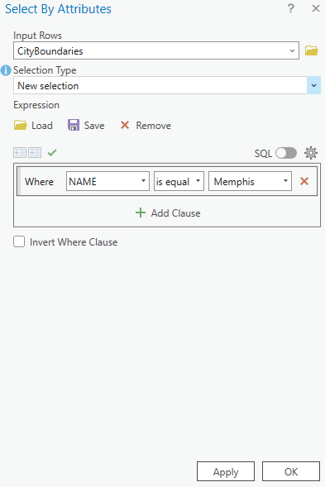

1. Next, you will make a layer from that selection by right-clicking the layer, hovering over Selection, and choosing **Make Layer From Selected Features**. Make this layer permanent by right clicking **CityBoundaries Selection**, hovering over **Data**, and choosing **Export Features**. Click the folder next to the textbox for **Output Feature Class**. Navigate to the **Hypertension.gdb** geodatabase and name the layer **Memphis**.

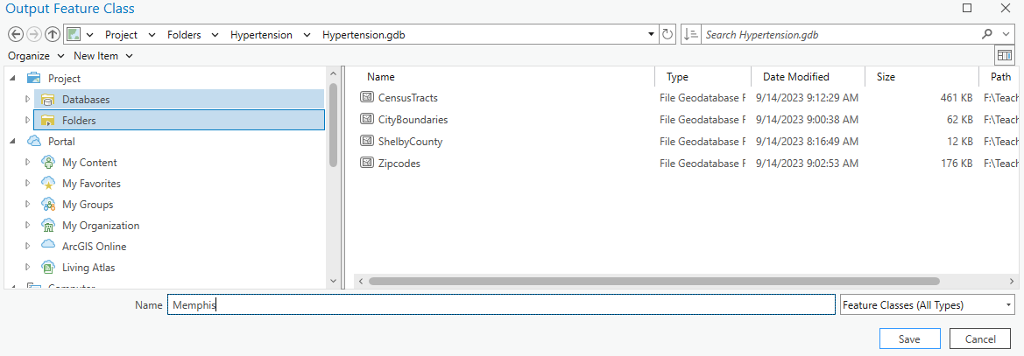

1. Click **Clear** at the top of the ArcGIS Pro environment to clear the selected features, remove the **CityBoundaries Selection** layer, and turn off the **CityBoundaries** layer. Then, right-click the **Memphis** layer and choose **Zoom To Layer**.

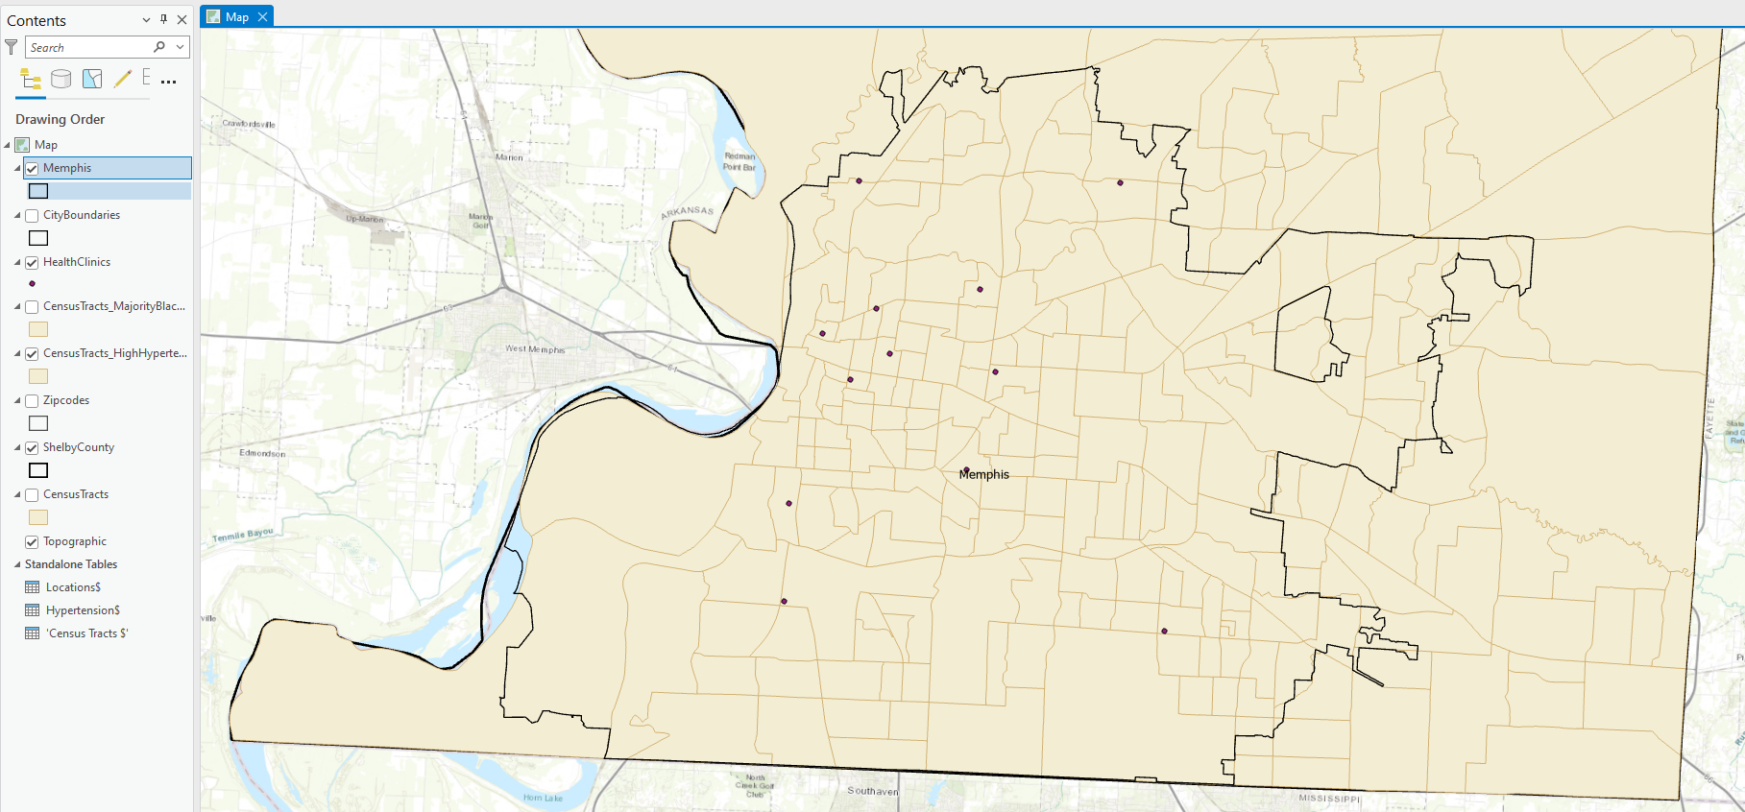

1. Next, we want to be able to visualize areas with high hypertension rates. To do this we can create a new field that is called **Hypertension** and assign areas that have high hypertension rates **High** and **Not High**. First, open the attribute table for **CensusTracts_HighHypertension**. Then, click **Add** at the top of the attribute table. This will open the **Fields View** with a new field on the bottom row for you to fill out. For **Field Name** enter **Hypertension** for **Alias** enter **Hypertension**. For **Data Type**, choose **Text**. Leave the rest alone.

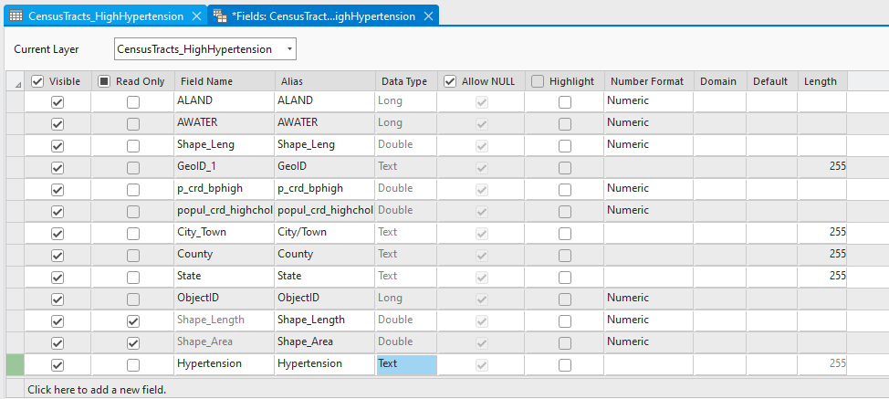

1. Click the **X** in the **Fields:CensusTracts_HighHypertension** tab to close the Fields View. A popup window will appear asking if you would like to save changes. Click **Save**. If you scroll all the way to the left of the **CensusTracts_HighHypertension** attribute table, you will see a new column labeled **Hypertension** that has all null values. Here we will use **Select By Attributes** to fill in these cells. First, you will click **Select By Attributes**, and choose where **p_crd_bphigh** **is null**. Hit **Apply** then **OK**.

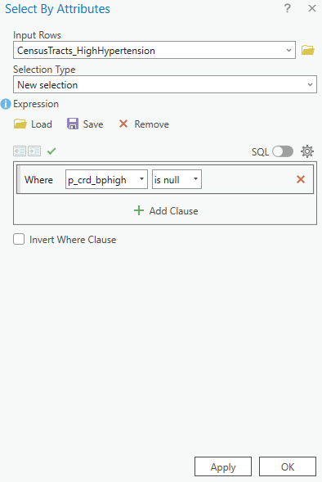

1. At the bottom of the attribute table, you will see figures showing rows that alternate between white and blue and only blue rows. This is how you can switch from looking at all the data to only looking at selected features. To look at only selected features, click the figure with only blue rows.

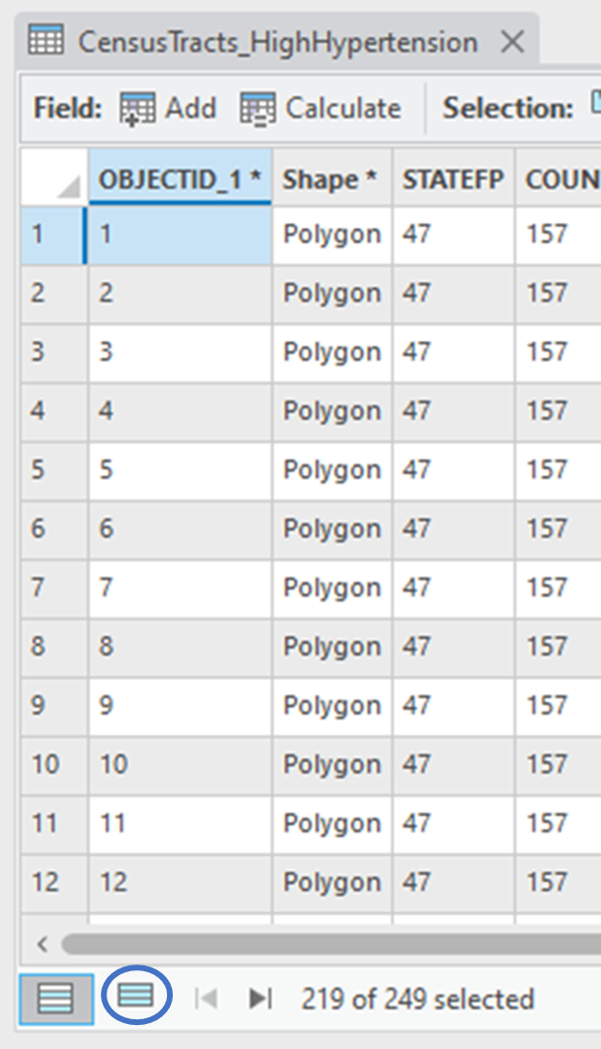

1. Because the data we had in the **Hypertension** excel spreadsheet only gave information for high hypertension census tracts, we can take all these null values for the selection (which has null values for the census tracts) and label them as **Not High**. To do this, right-click the **Hypertension** field and choose **Calculate Field**. In the textbox under **Hypertension =**  enter “**Not High”**. Then click **Apply**.

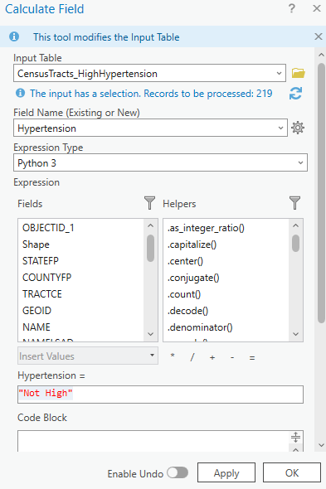

1. Next, you will click **Switch** at the top of the attributes table to switch the selection. This will make the selection change from all null values in the **p_crd_bphigh** column to the selected features being those whose **p_crd_bphigh** column is not null. You will notice that the **Hypertension** field for the newly selected features all have null values. We can assign them **High** by right-clicking the **Hypertension** field and choose **Calculate Field**. In the textbox under **Hypertension =**  enter **"High"**. Then click **Apply**. Next click **OK**. Finally, clear the selected features and close the attribute table.
2. Now we want to visualize areas with high hypertension rates different than those areas that do not have high hypertension rates. To do this, right-click the **CensusTracts_HighHypertension** layer and choose **Symbology**. Choose the dropdown menu under **Primary Symbology** and choose **Unique Values**. Next, choose the dropdown menu next to **Field 1** and choose **Hypertension**. Now you have the two classes: High and Not High. Double click the symbol next to **High** use the dropdown menu next to **Color** to choose **Medium Fuschia**. Click the back arrow at the top of the symbology pane to go back. Then, double click the symbol next to **Not** **High** use the dropdown menu next to **Color** to choose **No Color**. Click the back arrow at the top of the symbology pane to go back to verify it looks like the figure below. Close the symbology pane.

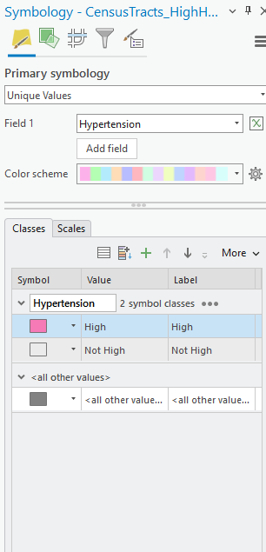

1. Next we will work with labels. We want to label the health clinics a very specific way. First, right‑click the **HealthClinics** layer and choose **Labeling Properties**. This brings up a pop-up window on the far right of the ArcGIS Pro environment. This process can be a bit more involved than other because you have to create an **Expression**. You can do this by double-clicking the field you want to use for the label, but you have to make sure that you delete all text in the **Expression** first. Let’s try it. Delete all the text in the **Expression** textbox, then double-click the **Practice/Partner Organization** under the **Fields box**. Click **Apply**.

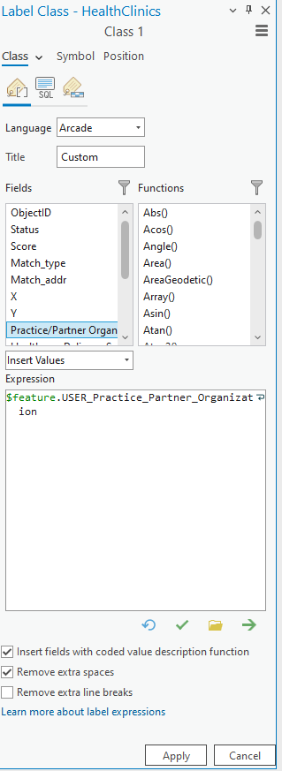

1. As you can see, the code in the **Expression** box now says “$feature.USER_Practice_Partner_Organization". If you right-click the **HealthClinics** layer, you will now see the name of the organization by each point location. This is a good start to labeling the features. However, viewers might want to know not only the organization’s name, but the health delivery system for that organization. To add this in and make it readable for the viewers, you would want to put the health delivery system in parentheses after the organization. This requires a more involved expression as there is no easy button click to include make parentheses around text. However, you can do it by adding a bit of your own coding to the **Expression** box. Delete everything inside the **Expression** textbox and type in the following code:

$feature.USER_Practice_Partner_Organization + ' (' + $feature.USER_Abbreviations_of_Health_Deliver + ')'

Then, click **Apply**.

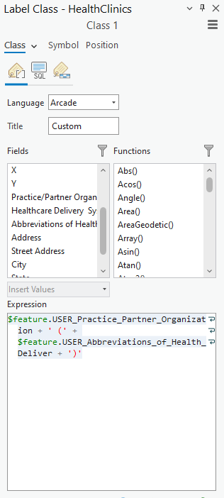

1. This is starting to make the map much more appealing but it still looks kind of busy. Let’s finish by cleaning it up a bit. First, change the basemap to **Light Gray Canvas**. Then right-click **CityBoundaries** and select **Labeling Properties**. Choose **Position** from the top of the pop-up window. Next, select the box next to **World Light Gray Reference** to turn off the labeling for the basemap.

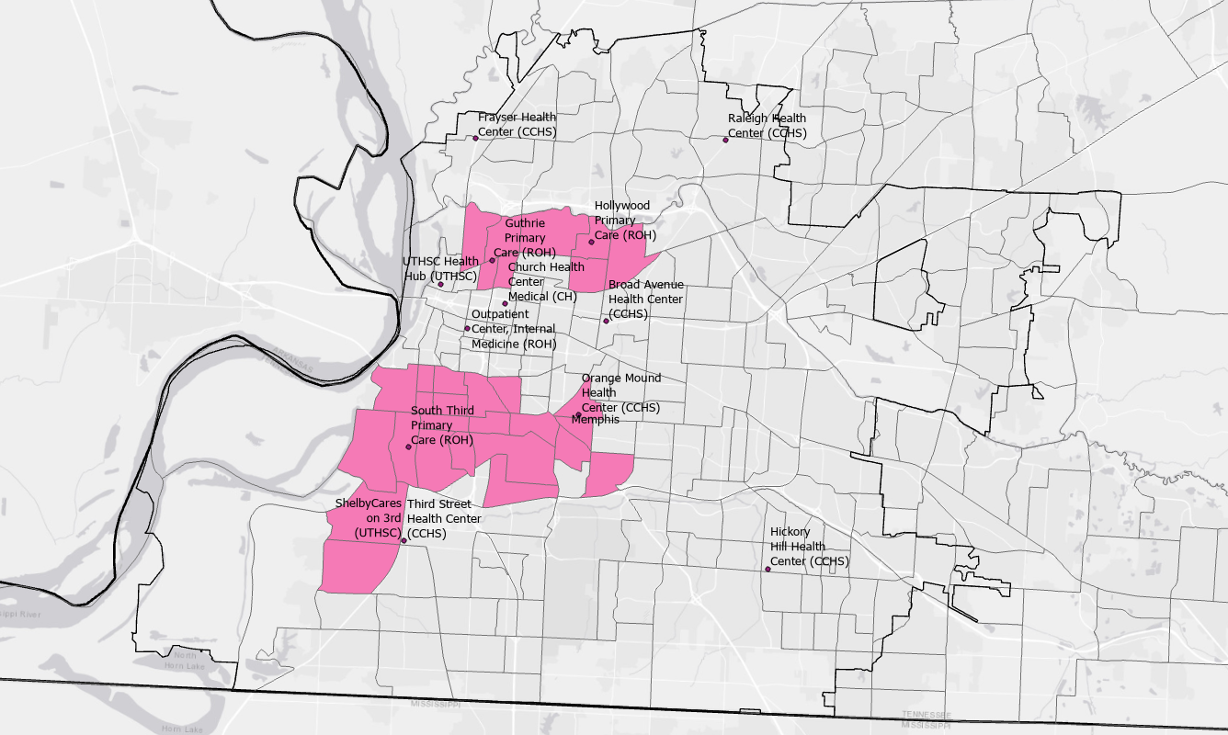

1. This looks cleaned up, but the label for Memphis is overlapping one of the health centers. We can reposition and make this label more visible by right-clicking the **Memphis** layer and choosing **Labeling Properties**. Select **Position** near the top of the pop-up window for the labeling properties window. Click the drop-down menu for **Horizontal in polygon** and choose **Horizontal around polygon**. Look at the wheel with numbers. This allows you to choose where you would prefer the label to appear. Change the values to reflect the figure below.

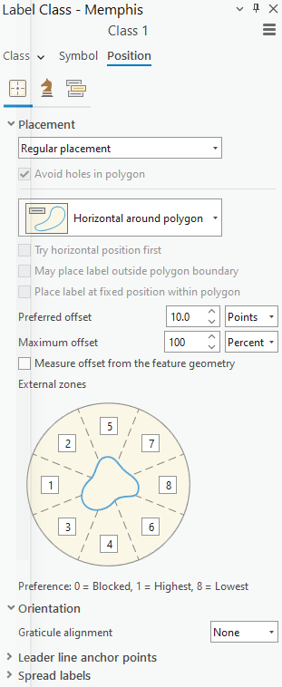

1. Then, click **Symbol** near the top of the labeling properties pop-up window. Under **Appearance**, use the drop-down menu to change the **Size** to **20 pt**. Click **Apply**.Next right-click **HealthClinics** and choose **Zoom To Layer**. The map is almost finished, all that is needed is a **Title**. However, you cannot add a title while in an active **Map** frame. You must create a layout for the map. ArcGIS Pro has some pre-made layouts you can choose from by clicking the **Insert** tab at the top of the ArcGIS Pro environment and selecting the arrow below **New Layout**. Under **ISO – Landscape** choose the **A3** layout. A new blank page will appear.



1. Towards the top of the ArcGIS Pro environment, select **Map Frame** and choose the image that looks like the map you created (located within the **Map** section). Then, click at the top left corner of the new blank layout and drag to the bottom right corner to encompass the entire page with the map frame. The map will look slightly off from what you created in the **Map** tab. You can fix this by right-clicking **HealthClinics** and choosing **Zoom To Layer**. Next, you will want to click the **Rectangle Text** from the **Graphics and Text** menu along the top of the ArcGIS Pro environment.

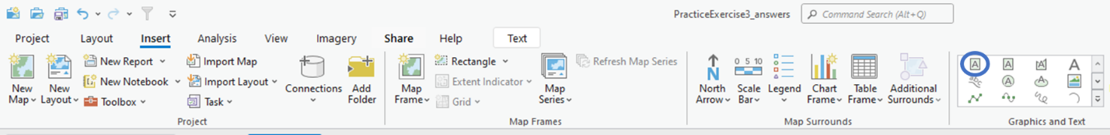

1. Next, click at the top-left of the map layout and drag down and to the right until right before the point location for **Frayser Health Center (CCHS)**. Then double-click in the text box and an **Element** pop-up window will appear on the right-hand side of the ArcGIS Pro environment. Within this pop-up window, click inside the text box and delete **Text**. Then type in **Census tracts with crude adult hypertension prevalence of 53% or higher**. Change the **Margin** to 2 mm. Click the box with a paintbrush (when you hover over it, it will say **Display**) Click on **Text Symbol** towards the top of the pop-up window. In the **Background** section, click the drop-down menu across from **Symbol** and choose **Arctic White**. Click the **Text Symbol** tab and for **Size, choose 18 pt**.

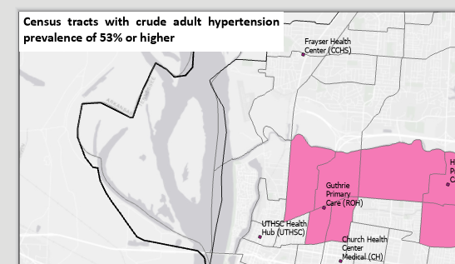

1. On the map layout, resize the text box, so everything fits on one line. Move the text box, so it is not touching the border of the map layout.

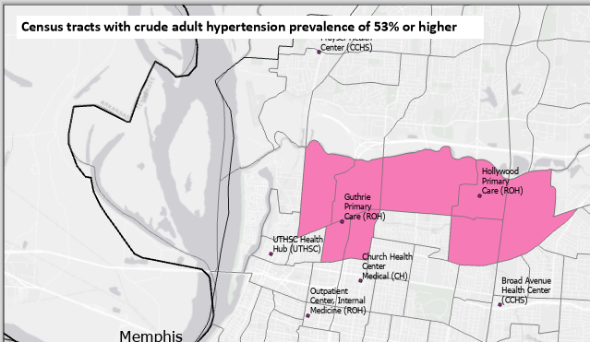

As you can see, the title is now covering over the name of **Frayser Health Center**. You can zoom out a little on your map to make sure that all health centers and census tracts are visible. At the bottom left of the map, there is a ratio number in a text box. Change that to saying **1:78,000**.

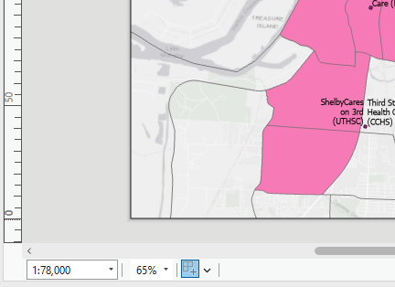

1. Next you will want to save your map as an image on your computer. Click the **Share** tab at the top of the ArcGIS Pro environment, then choose **Export Layout**. In the pop-up window on the right-hand side, make sure that **File Type** is **PNG**. Click the folder button next to the name textbox and navigate to the folder you are saving your exercise answers in. Name it **Final Hypertension Map**. Then click **Export**.

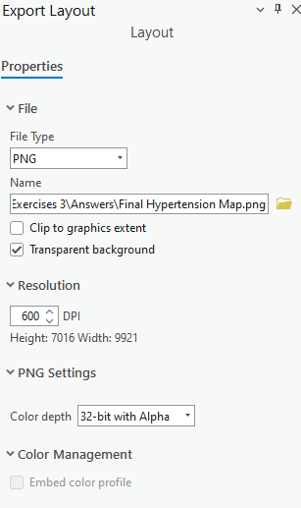

**Section 3.1 Task:** Submit the **Final Hypertension Map.png** along with your exercise answers.